Jack Lunar Lander
Functional Specification
Brian Hoenes
CSCI 598, Elements of Computing
March 29, 2011

Overview
This program is Jack implementation of the 1979 Atari Lunar Lander arcade game. The reason for implementation of the game is to build a non-trivial Jack program. The game is a 2-D side view with vector graphics and consists of a lunar lander dropping from sky that the player attempts to land safely on rocky terrain using a main thruster on the bottom of their lander and rotational thrusters.

Graphics
The graphics will be 2-D vector graphics. The view is a side view with the moon surface at the bottom of the screen. Status readouts will be provided for altitude, horizontal velocity, vertical velocity, fuel remaining, elapsed time, and score. A screen shot of the original game is shown to the right in Figure 1.
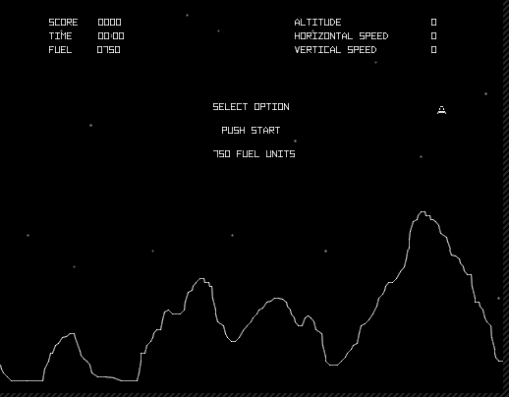Figure 1: Atari Lunar Lander (1979)

Game Play
From Wikipedia, the objective of original Lunar Lander was to pilot a lunar landing module as it prepares to touch down on the moon. The terrain is very jagged and has only a few flat areas appropriate for landing. These areas are highlighted with a flashing bonus multiplier, which is higher for smaller areas. If the player successfully lands the module, he or she is awarded points based on how good the landing was and the difficulty of the landing site. If he or she crashes, points are awarded based on the severity of the crash and sometimes the player receives a fuel penalty. In either case, the game starts another round with a different set of terrain and the player's remaining fuel. The game is over when the player has run out of fuel and crashes on the moon's surface.

To pilot the lander, the player must counteract gravity by using the lander's aft thrusters to slow its descent. In the arcade game, the player used proportional throttle to adjust the strength of the thrusters. To support standard keyboards which do not support proportionality, this version will support a throttle that increases thrust in relation to time but is either on or off. Three buttons provide the ability to rotate the craft clockwise and counterclockwise, and to "abort" an approach by firing the thrusters at full strength for a short time. In this implementation, the up arrow will activate the main thrusters providing acceleration along the main axis of the lander. The right and left arrows provide rotational acceleration to the lander. Each action uses up the craft's limited fuel, and when fuel has run out, the lander stops responding to the player's actions. In a deviation from the original game, the lander will conserve rotational momentum.

Physics
The lander will be affected by the accelerations from thrusters (main and rotational) and the acceleration of the gravity from the planet they are landing on. Momentum will be conserved vertically, horizontally, and rotationally.

